**Will Pond**

**Task1**

**Using printenv to print out the environment variables**

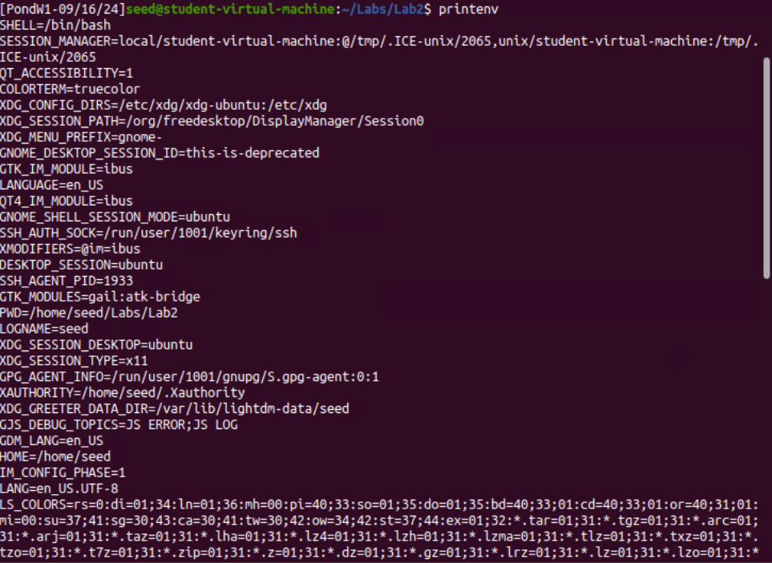

**Getting particular environments variables from env | grep command of PWD**

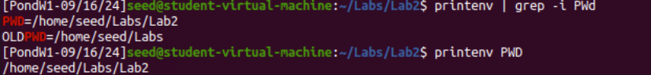

**Using env to print out the environment variables**

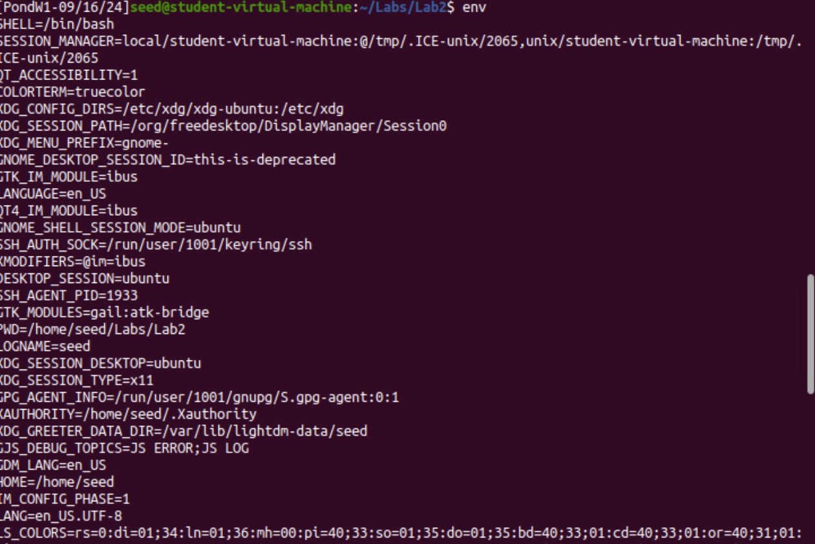

**Using the export to set environment variable SEEDAGE and then echoing in to get 5**

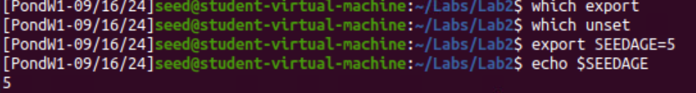

**Unset the environment variable SEEDAGE and echoing in to prove that is has been unset**

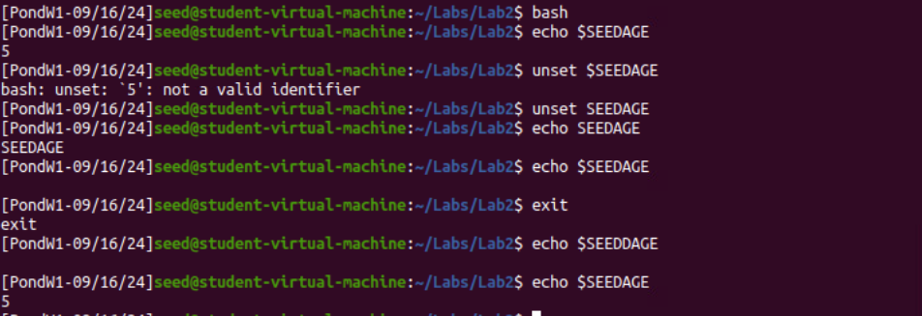

**Observation**

**I have observed that printenv and env can print out environment variables and they are like one another. I observe how to set and unset eniroment variables by using export and unset because shell command. Also, when I exit the child process the environment variable is set set because the child process gets a copy of the environment variable.**

**Task2**

**Fork() instruction after typing in the command man fork**

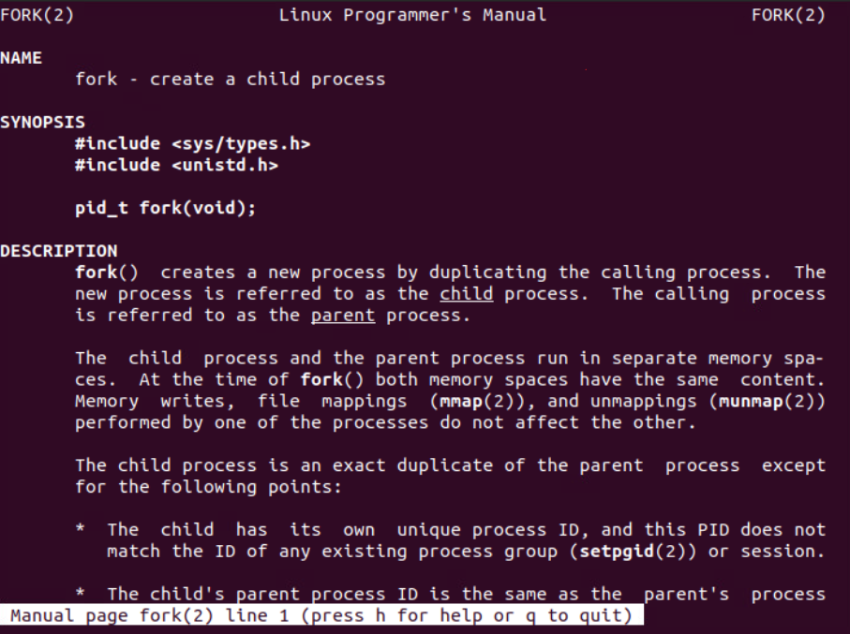

**Code for myprintenv.c and using the child process printenv();**

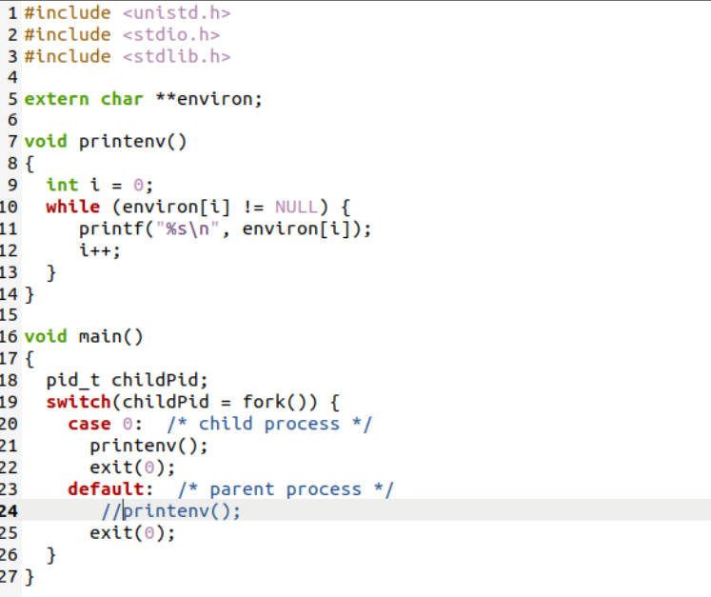

**Compling myprintenv.c and getting a binary called a.out. Running the a.out to get the eniroment variables and then saving it to a file name file. Then change a.out to file1**

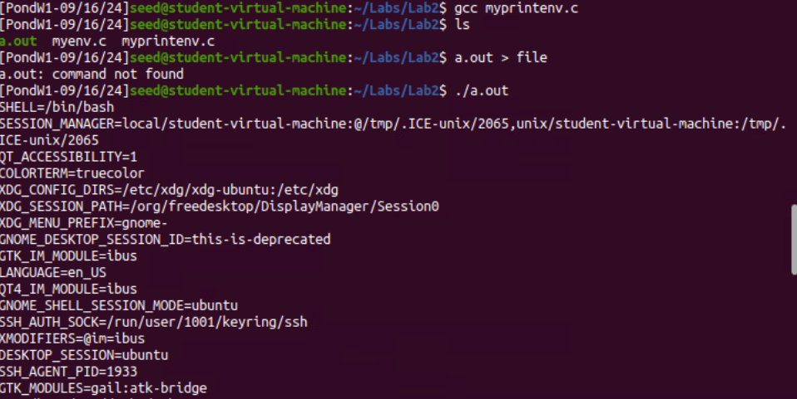

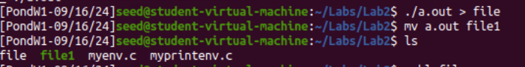

**Code for myprintenv.c and using the parent process printenv();**

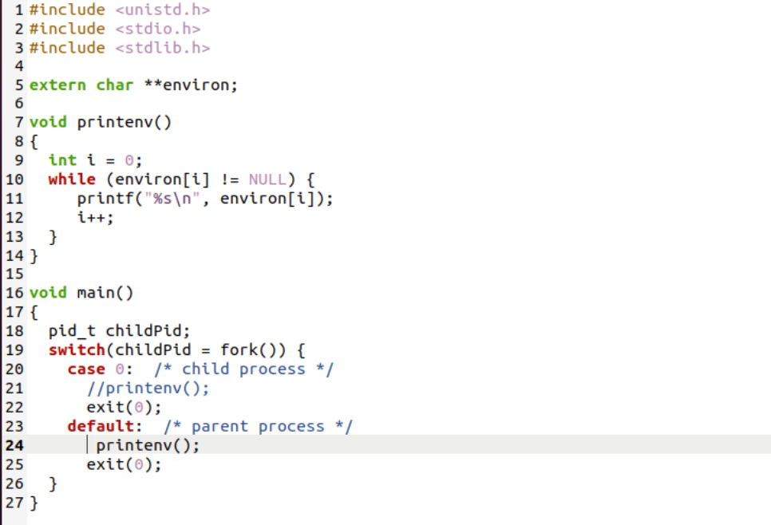

**Creating a duplicate file of myprintenv.c and naming it file2. Then creating more duplicate name file and parent_file. file is the child process file and parent file are the parent process file. Then use the diff command to difference. What I draw from this is that they both have the same environment variables.**

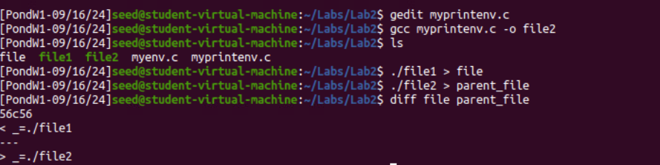

**Task3**

**Code of myenv.c using NULL in the third argument of execve**

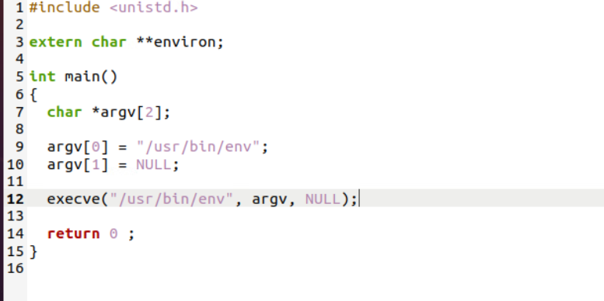

**Code of myenv.c using environ in the third argument of execve**

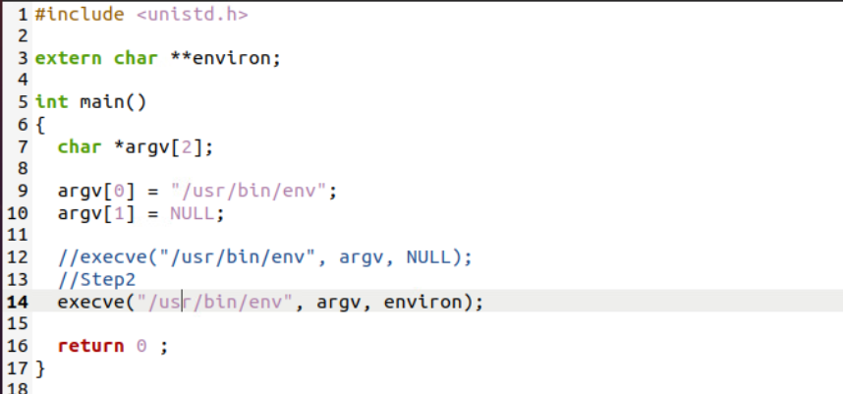

**Making duplicates of the myenv.c file with different modifications to it named task3 then rename to myenvl. Then name myenv2 and run it to get environment variables. Inconclusion if you have NULL in execve() you will get environment variables but if you have environ in the execve() you will get environment variables**

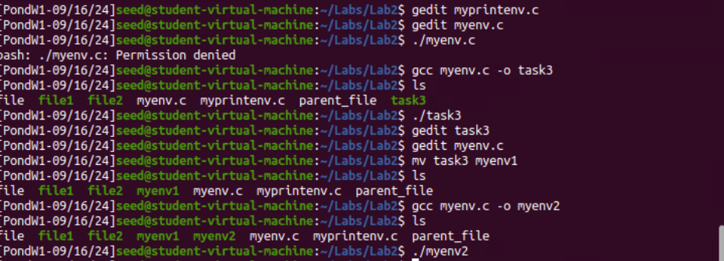

**Environment variables of myenv2**

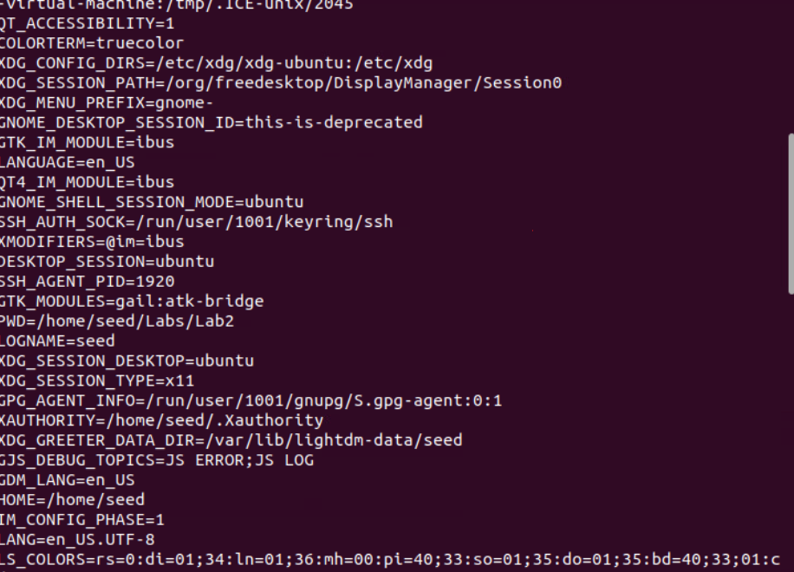

**Task4**

**Code for task4.c**

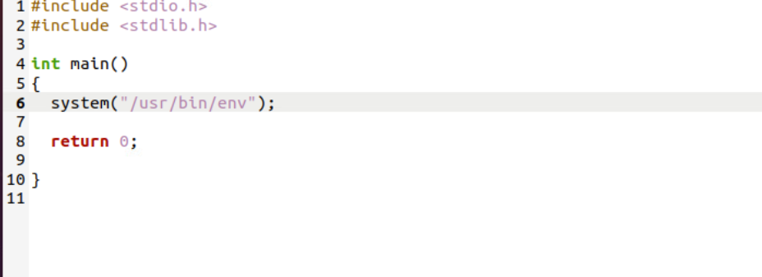

**Creating the c file and writing it and duplicating to callsys to run it**

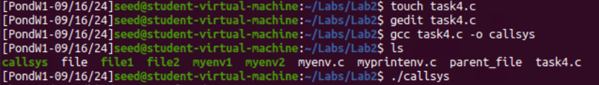

**Getting environment variables of callsys**

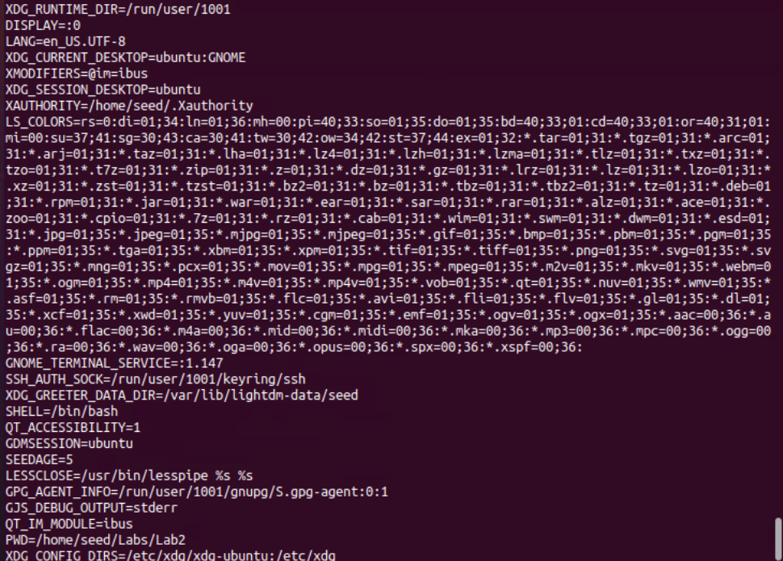

**This is verified of calling process is passed to a new program /bin/bash**



**Task5**

**Code for task5.c**

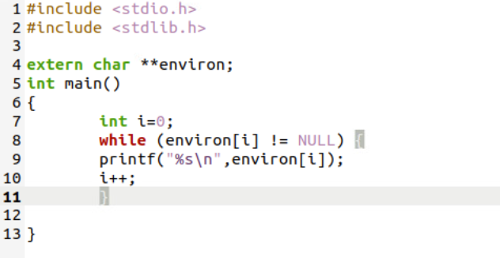

**Creating task5.c and writing code. Then duplicate it and name it task5. Then changing ownership of the program to root and making it a Set-UID program.**

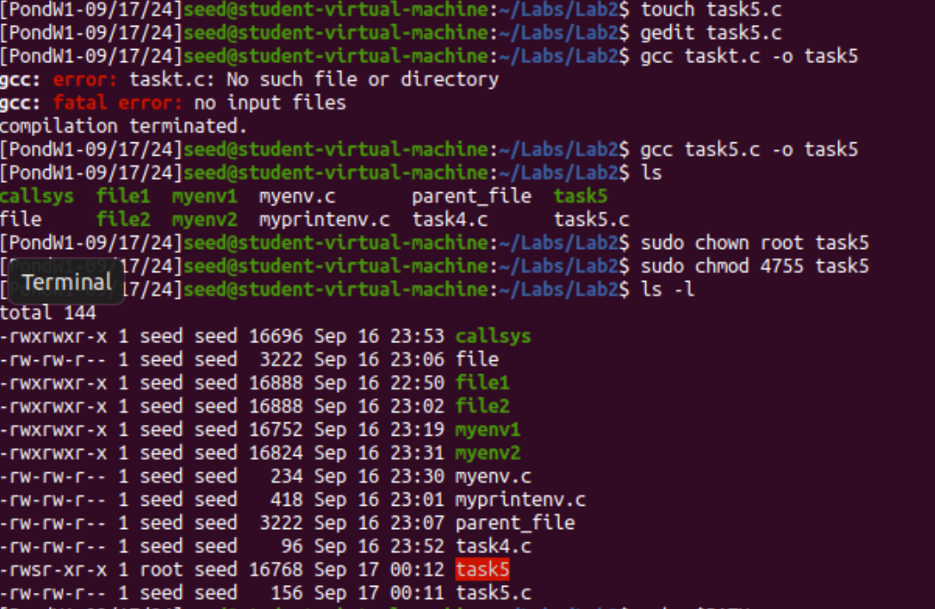

**Setting environment variables but some already have environment variables but not all environment variables get in the Set-UID. In my observations my of the environment variables in the shell don’t make it in the Set-UID program which that did surprise me.**

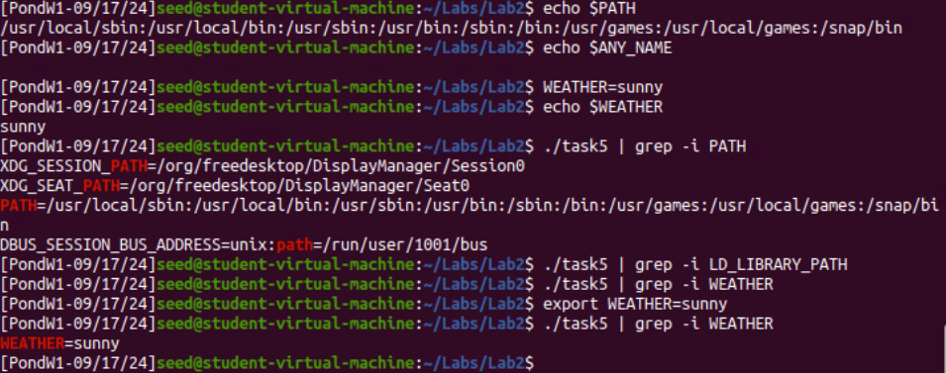

**TASK6**

**Code for task6.c**

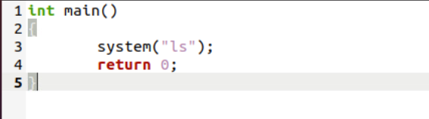

**Creating the c file and writing then duplicating. The duplicate is task6 then change it to root**

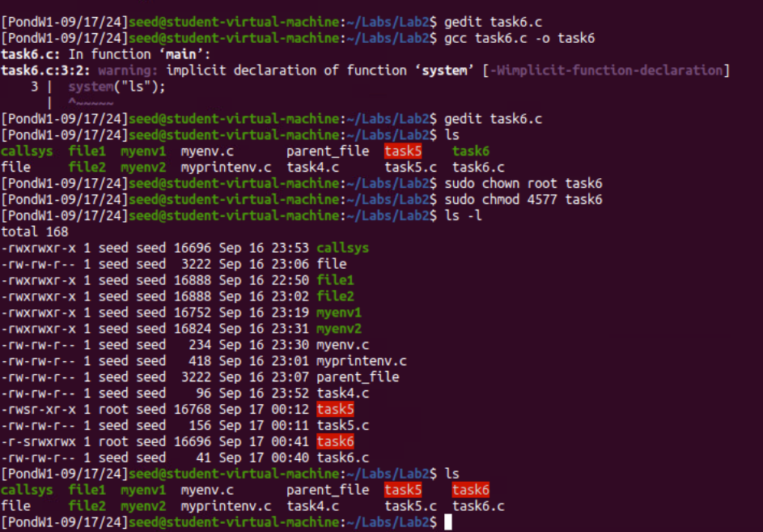

**Code for ls.c**

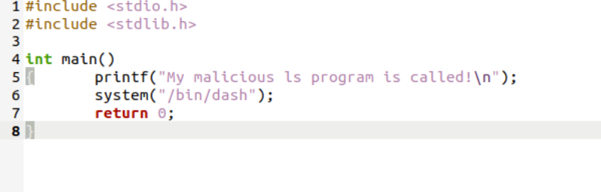

**Creating ls.c file and writing the code then creating duplicate name ls**

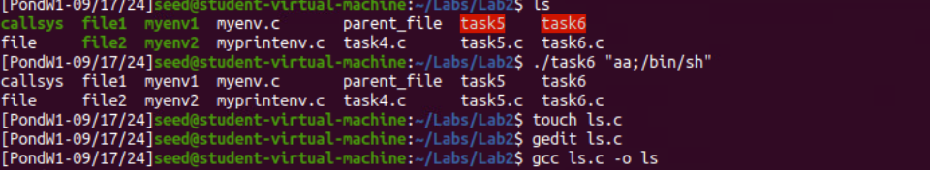

**Then setting the Path environment variable**

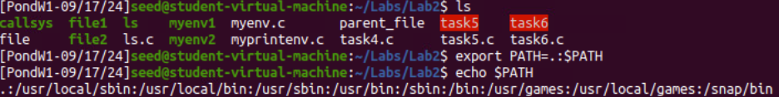

**Running task6 to deploy the malicious program of ls**

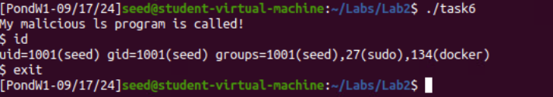

**Linking the /bin/sh to /bin/zsh and then running the attack**

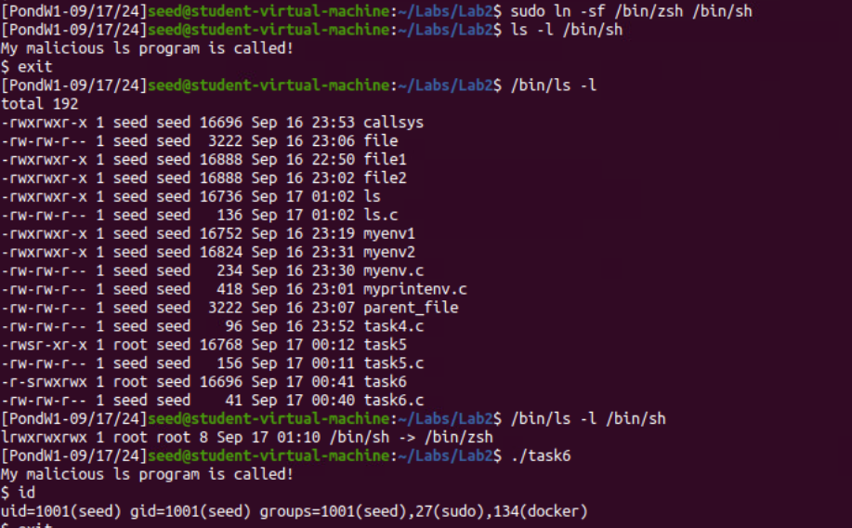

**TASK7**

**Code for lib.c**

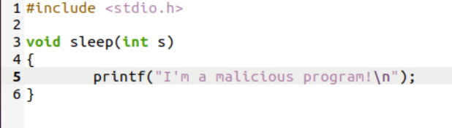

**Code or myprog.c**

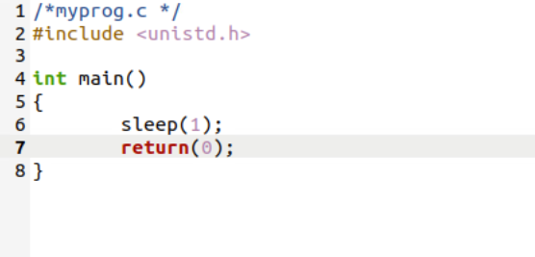

**Scenario 1**

**Creating the c file mylib.c and writing code then compiling the mylib.c. Next setting the LD_PRELOAD environment variable and creating the c file myprog.c to write code to. Then creating a duplicate of myprog.c called myprog and running it get the output of “I am a malicious program!”**

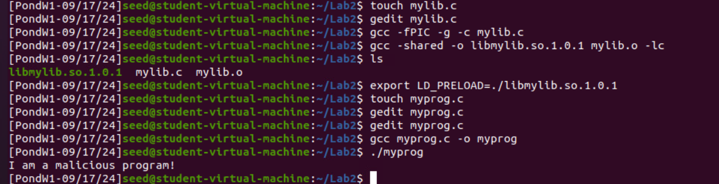

**Scenario 2**

**Making myprog a Set-UID root program to normal user and running it**

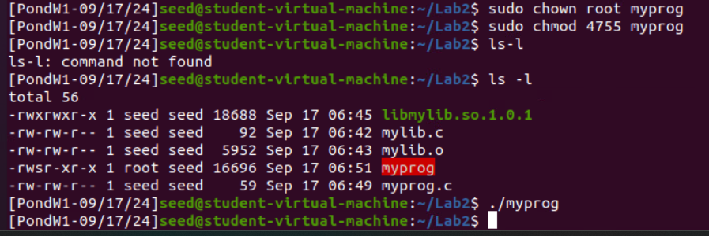

**Scenario 3**

**Make myprog a Set-UID root program to a root user and exporting the LD_PRELOAD environment variable to get “I am a malicious program!”**

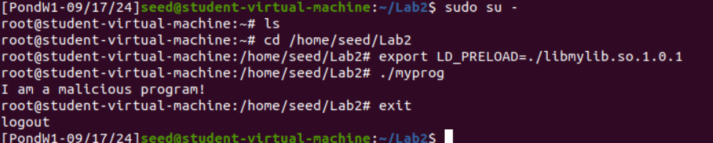

**Scenario 4**

**Creating user1**

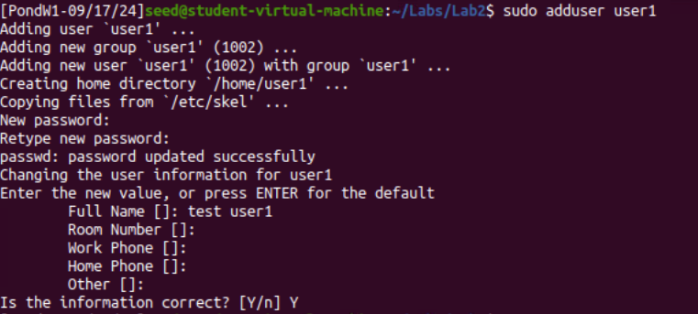

**Copying myprog and naming it myprog1**

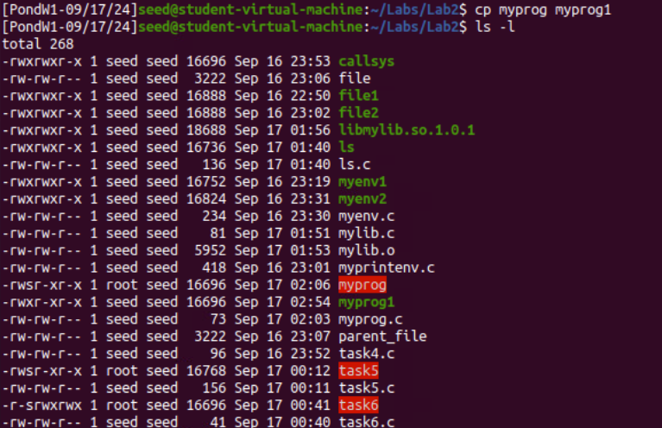

**Change myprog1 ownership to user1 and then run it. Also verifying that the LD_PRELOAD is still there**

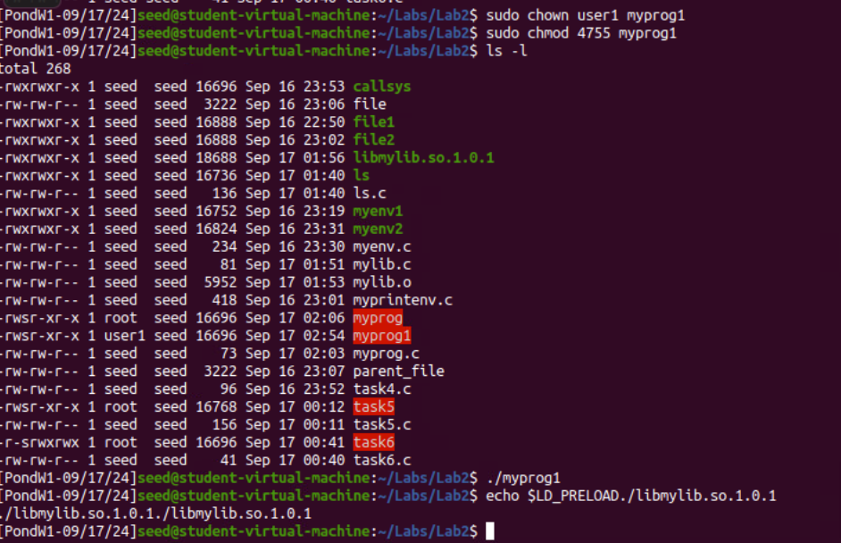

**Observation**

**I have observed different scenario to attack from myprog program but some scenario it was able to attack. I tested out the environment variable to see if they were still there and even with the environment variable the program could attack. Scenario 2 did not success because it was Set-UID as normal user not root also with Scenario 4 same thing not a root user which that surprise me.**

**Reflection**

**In this lab I had to do 7 tasks, and each one is due to an environment variable. Task1 was manipulation environment variables export and unset. Task2 was Passing Environment Variables from Parent Process to child and comparing them. Task3 was Environment variables with execve() which you want to you environ to run the environment variables if not it going to be NULL and it will not work as intend. Task4 Environment Variables with system() verifying the environment variables of calling process is pass to new programs like /bin/sh. Task5 was Environment Varible with set-UID so change ownership to root and testing out the environment variables to see if there was any environment variables before resting them. Task6 is the Path Environment variable and Set-UID Programs again but make a program to attack from the ls command. Finally, Task7 is the LD_PRELOAD Environment variable and Set-UID Programs to go over Scenarios of root ownership and not root ownership to see who can defend against the attack. Also, the sleep function override to attack.**